**Step-1**

**Select your linux instance and click🡪connect**

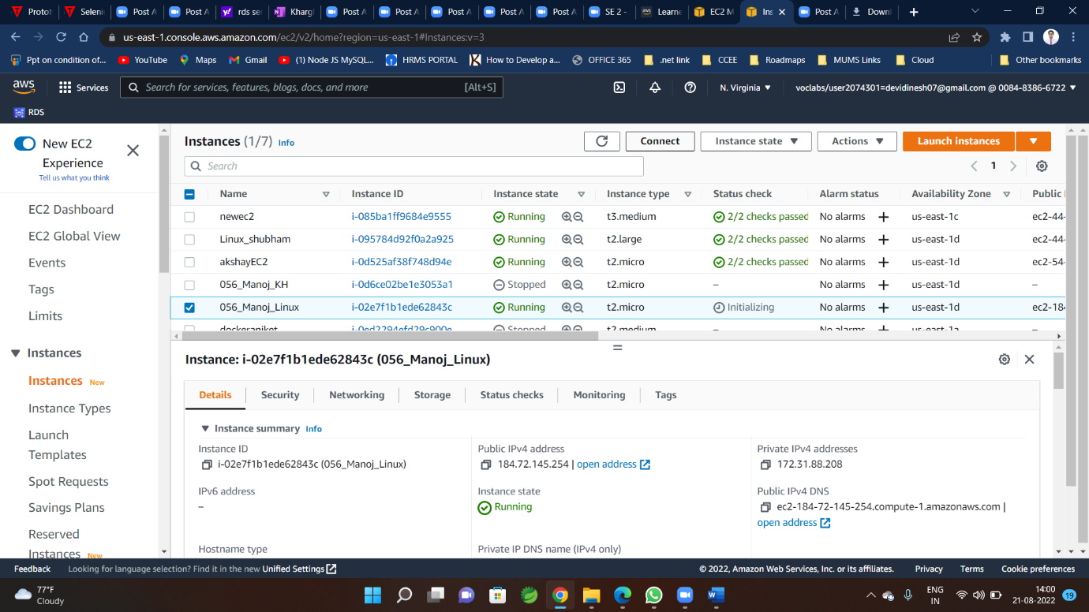

**Step-2**

**Click on SSH client (you will get commands here )**

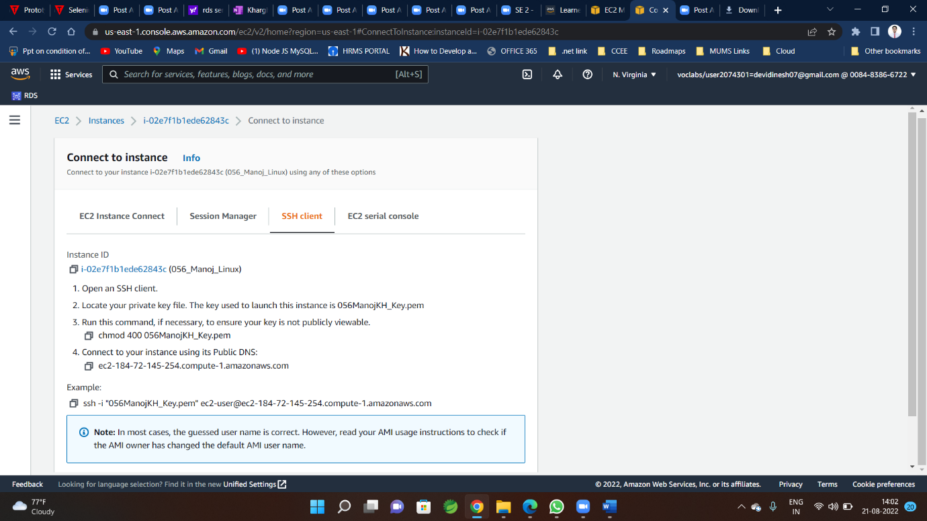

**Step-3**

**Download and open MobaXterm**

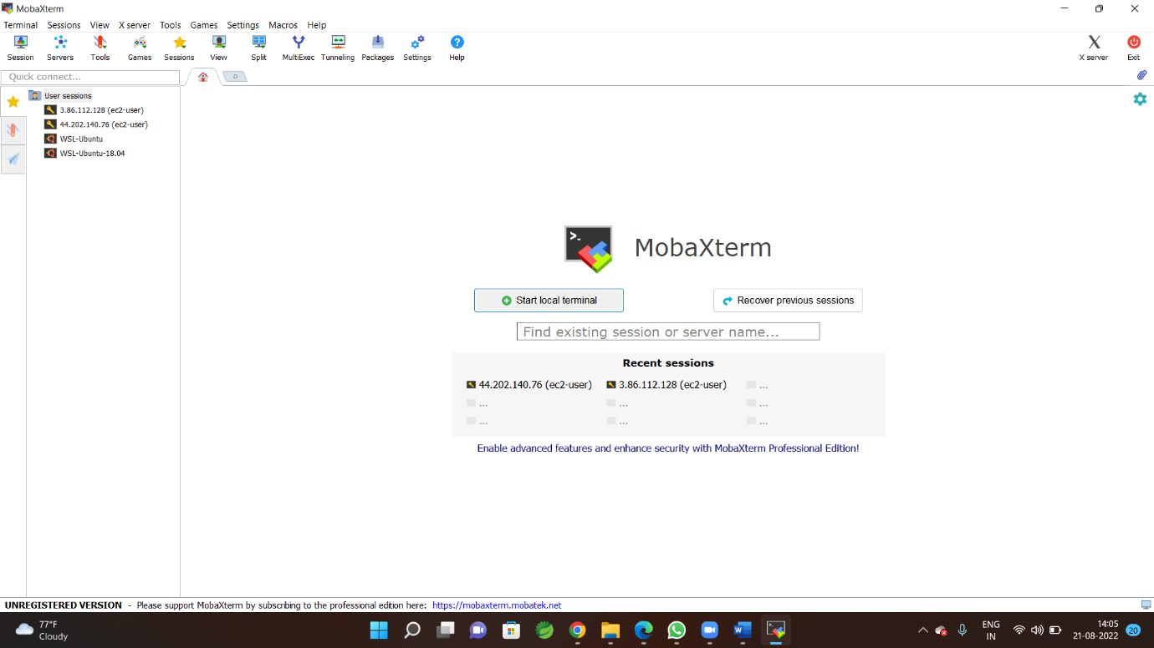

**Step-4**

**Click on Session**

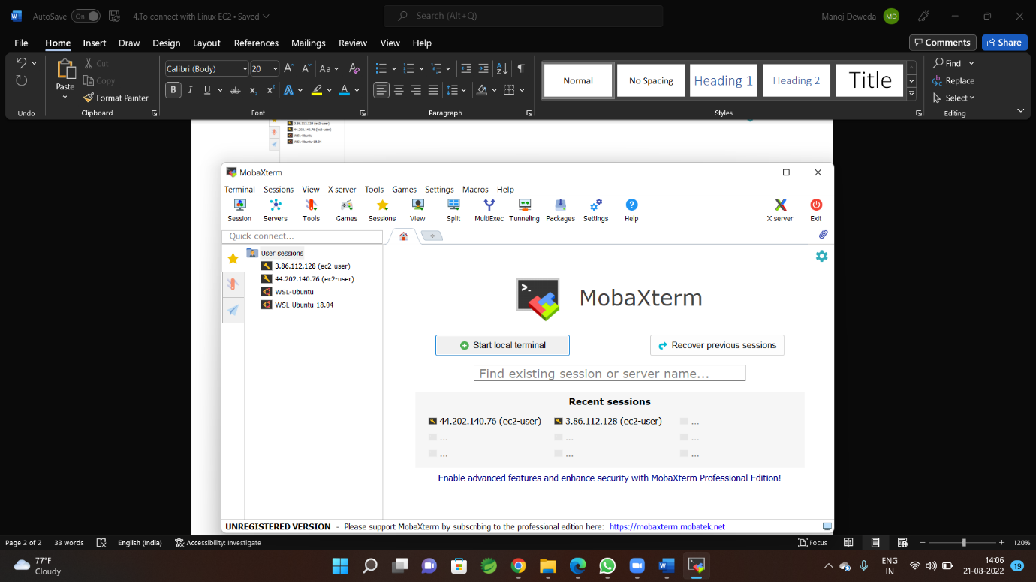

**Step-4**

**you will be redirected to new window as follows**

**Click on SSH**

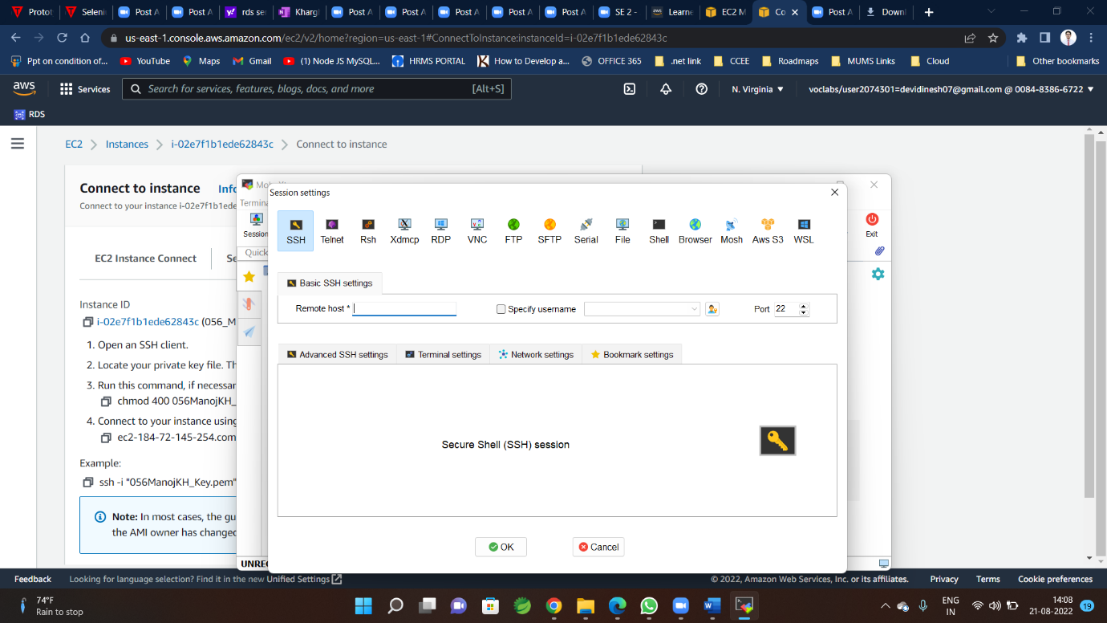

**Step-5**

**Copy public IPv4 address**

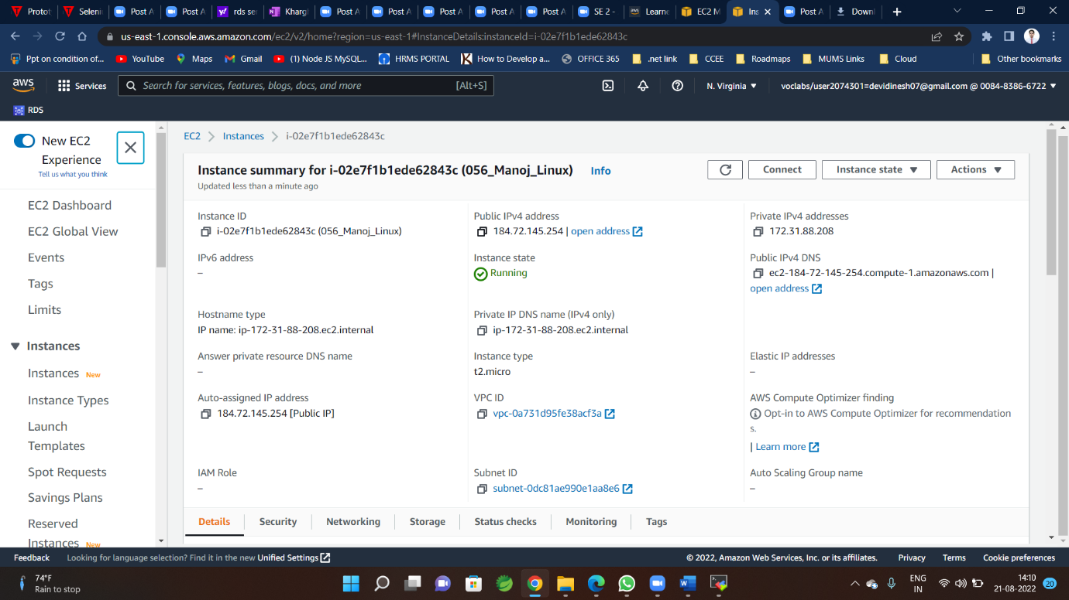

**Step-6**

**Paste IPv4 address here(in place of Remote host )**

**Username –(ec2-user)**



**Step-7**

**Click on Advanced SSH settings**

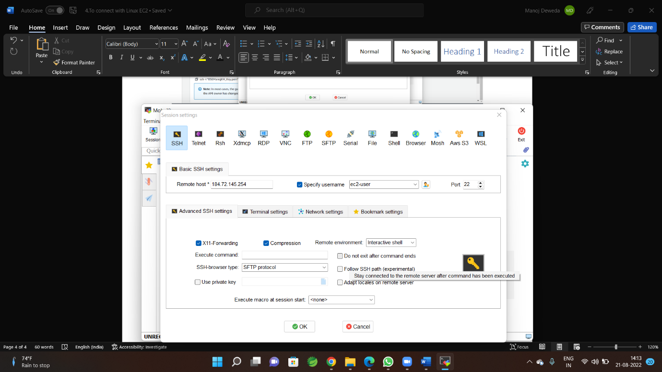

**Brows private key**

**Click on Ok**

**Step-8**

**You will redirected to following window**

